**PURCHASE CONTRACT**

**Definition of Purchase Contracts**:- Purchase contracts are used to register specific agreements with a buy-from business partner to delivery of specific goods.

**Purchase Contracts:-**There are two types

1.Normal Contracts.

2.Special Contracts.

1. **Normal Contracts**:-Normal Contracts are the contract that are general contracts done with the suppliers
2. **Special Contracts**:-Special Contracts are the contracts that are specially specified contracts done with the supplier.

**These Origins are used to search the purchase contracts**

1. Purchase Order line
2. Purchase Schedule
3. Planned PRP(Project Resource Planning) purchase orders in projects .
4. Planned purchase order in Enterprise Planning

**Setup for purchase contracts:**

* First we need to enable the check box in the purchase parameter (tdpur0100m000)

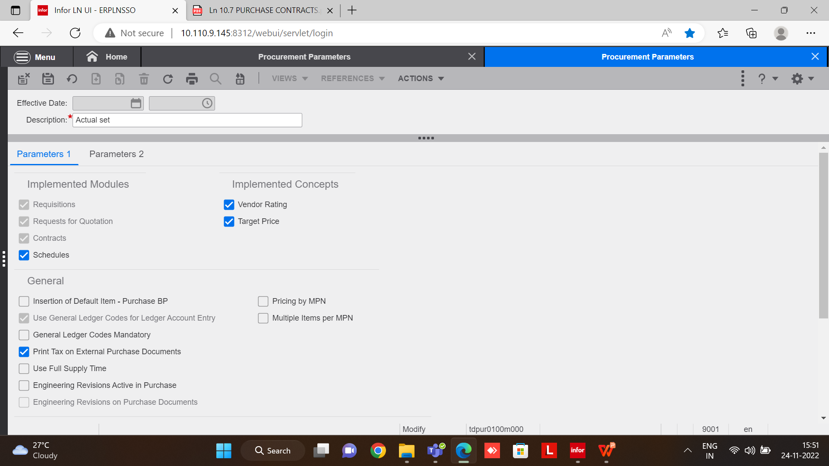

* Need to set-up purchase contract parameters(tdpur0100m300)

as per our requirement

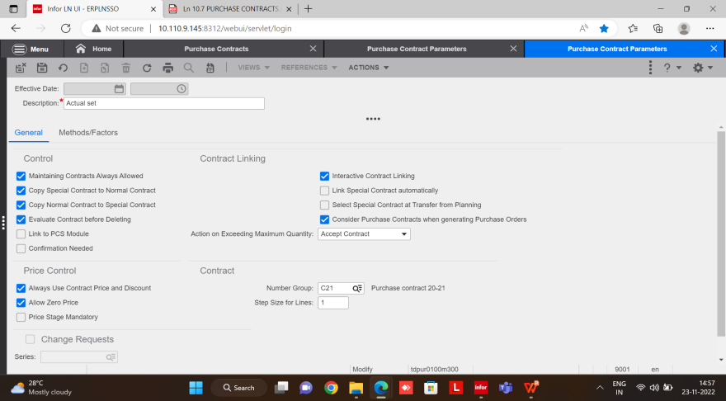

**Purchase contracts(tdpur3100m000):**

**Procurement**

**Contracts**

**New**

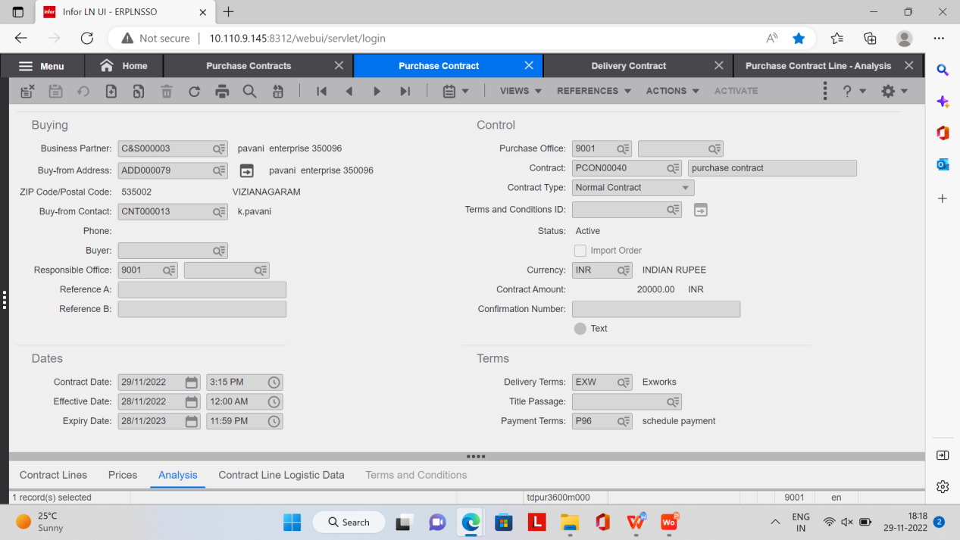

**Mandatory fields in header level:-**

* BP
* contract type
* description
* currency
* Purchase Office
* contract Date
* Effective Date
* Expiry Date

**Save**

**Mandatory fields in line level :-**

* Purchase office
* Item
* Agreed Quantity

**Pricing tab:-**

* BP Prices/Discounts or Buy-from Business Partner

**Contract lines:-**

* In contract line need to enable **Delivery contract** check box.
* Specify the delivery dates and the quantities to be delivered on the specified dates in the Delivery Contract (tdpur3104m000) session
* In the Delivery Contract (tdpur3104m000) session, select **Generate**

**Purchase Orders** to generate purchase orders for the planned deliveries in the **Generate Purchase Orders** (tdpur3204m000) session

**Active the purchase contract**

**Purchase contract status:**

1. Free
2. Active
3. DE-active
4. Terminate

**Restrictions for purchase contracts::**

* we need to enter the purchase office otherwise we are not able to do the transaction
* If we want to update any field, an **Active** contract must first be DE-activated (set to **Free**), before it can be updated

**Analysis:**

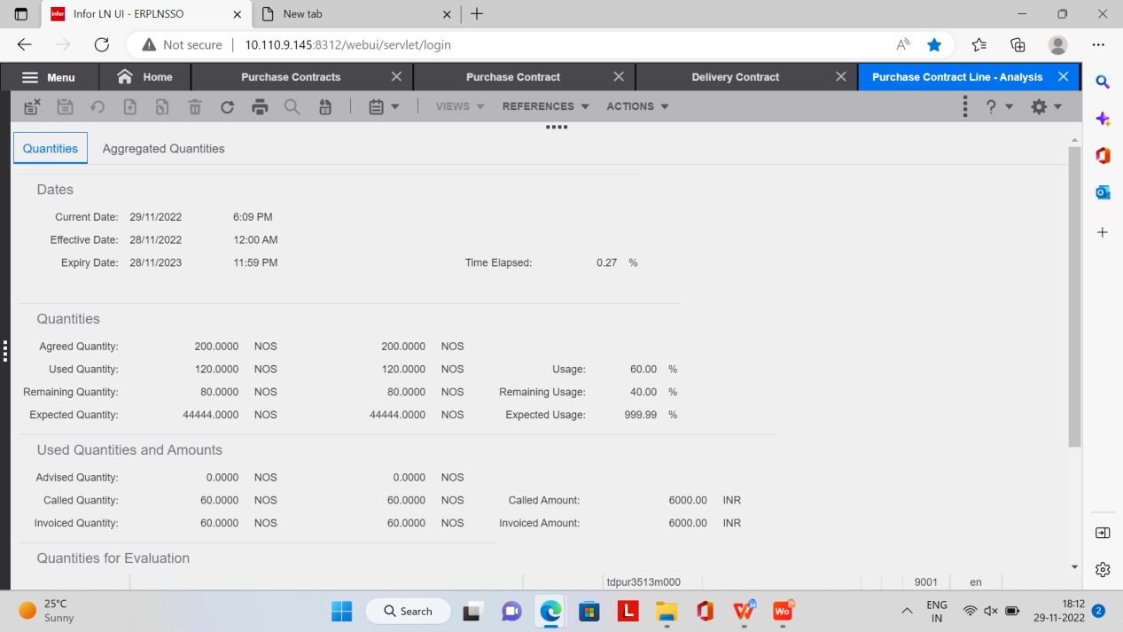

**Quantity** :

**Agreed quantity :** contract quantity

**Used quantity:** purchase order generated quantity

**Remaining quantity:** contract quantity -used quantity

**Time Elapsed :** ((current date-effective date)/((expiry date-effective date)+1))*100% .

**Example:-** Current date :- 29-11-2022

Effective date :-28-11-2022

Expiry date:- 28-11-2023

29/11/2022 -28/11/2022  * 100

28/11/2023 -28/11/2022+1

1

366*100

= 0.27%

**Expected quantity:**(used quantity/elapsed time in %)*100%

Example:- Used Quantity =120

Elapsed Time =0.27%

120 *100%

0.27%

=44444.00

**Used quantities and amounts;**

**Advised quantity**:After generating purchase order /purchase schedule created status quantity.

**Called quantity:** After generating purchase order /purchase schedule after created status to still invoiced status.

**Invoiced quantity:** After invoice approved quantity.

**Note:- As well as We Can do like this also**

* We can create purchase contracts before dates.
* If we add more quantity in Purchase Order that order linked to a Delivery contract that added quantity will be added in purchase contracts analysis line.

**If change request check box enabled:**

Middle of the contract if we need to change any field at that time we use **change request (tdpur3600m100)** this session to change the fields

**Setup for Change request :**

In **purchase contract parameters(tdpur0100m300)** we need to check the check box **change request**

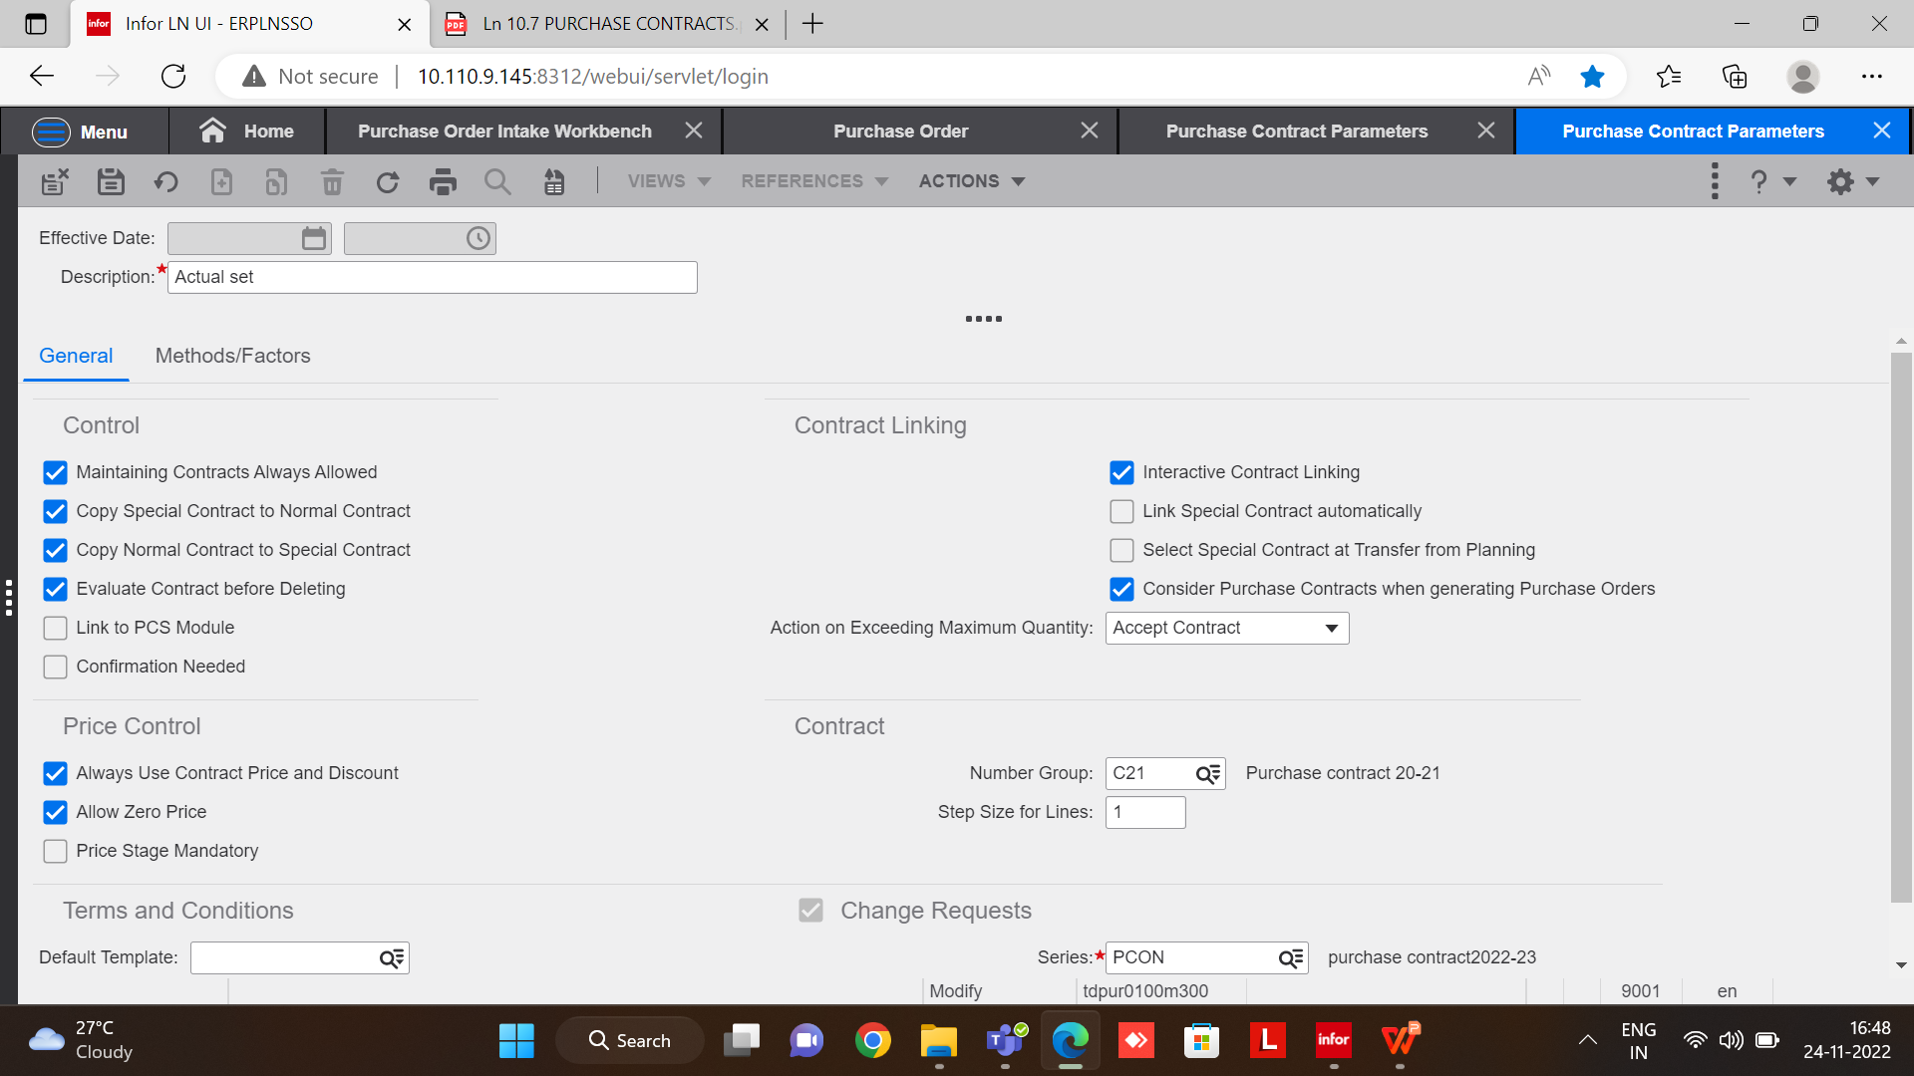

After we need to click the **Initiate change request**

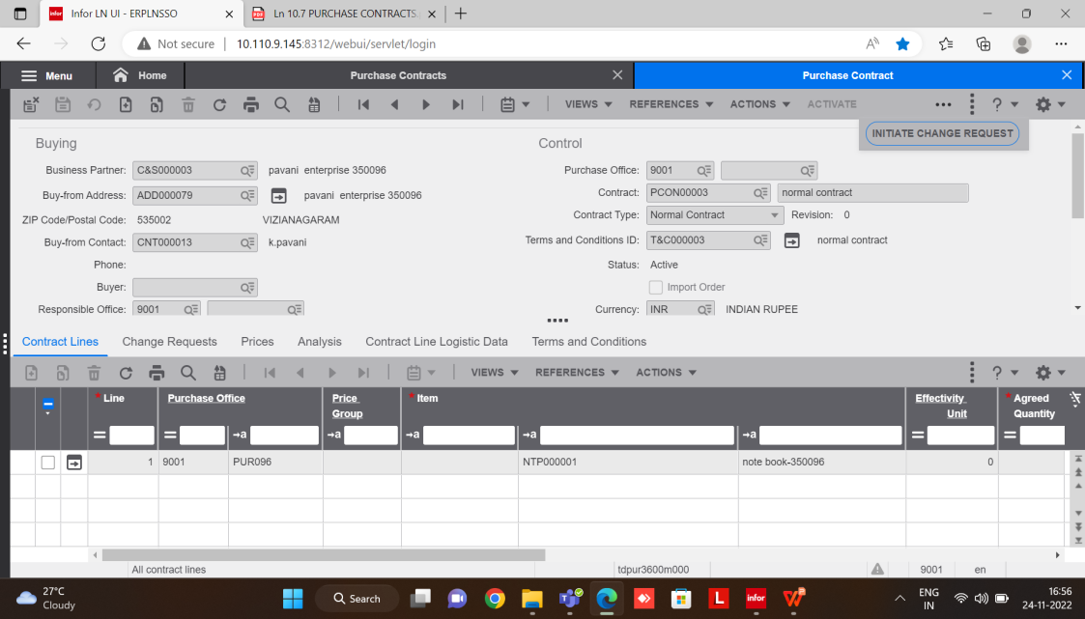

Then change request session will be opened at that time status will be **created**

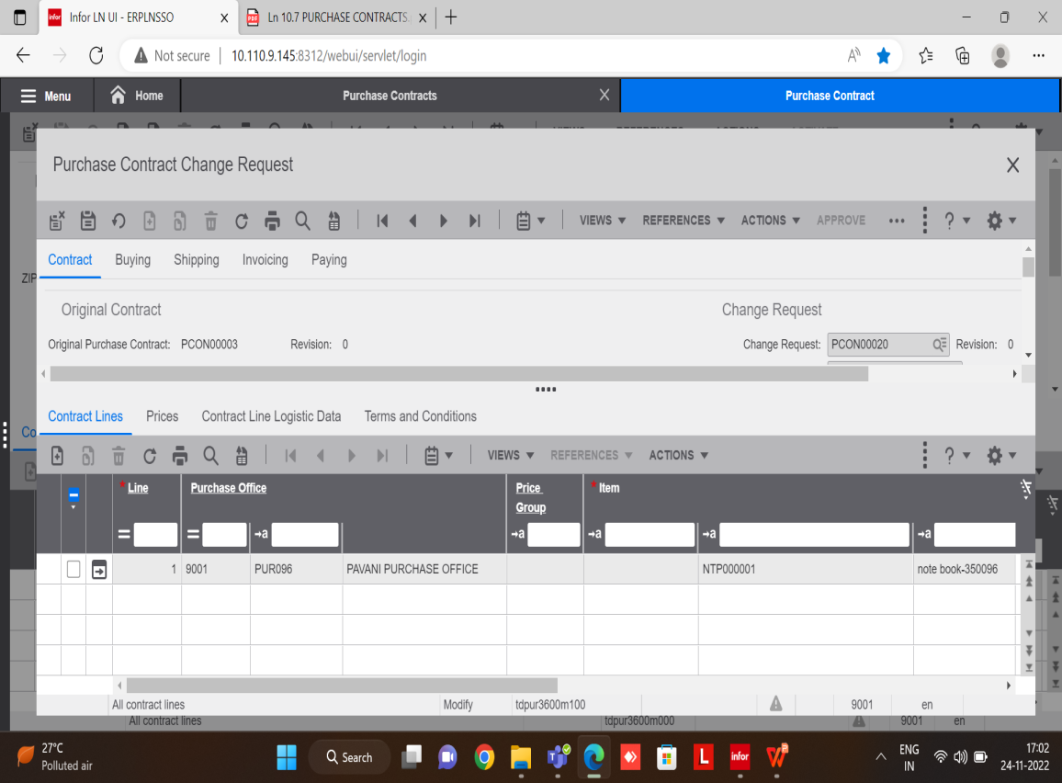

After changing the fields we need to approve the change request

|  |  |
| --- | --- |
| **Category** | **Fields** |
| Pricing terms | Price Stage, Price, Discount |
| Delivery terms | Delivery Terms, Ship-from Address, Receiving address (warehouse), Delivery Location, Delivery Date, Ship-to BP, Carrier |
| Payment terms | Payment Terms, Payment Address, Point of Title Passage |
| Order reference | BP Order Number, Reference A, Reference B, Buyer, Text |
| Quantity | Agreed Quantity |
| Item | Item, Manufacturer Part Number, Unit Effective Number, E-Item Revision |
| Sourcing | Preferred, Receiving Quantities, Lead Times, Schedule Message Types, Authorizations |

**Field update requirements**

This table lists the status of the purchase contract (PC) and the required criteria to update the purchase contract fields:

|  |  |  |  |
| --- | --- | --- | --- |
| **Category** | **Free (inactive) PC** | **Active PC** | **Terminated PC** |
| Pricing Terms | PC can be changed | Change request required to update PC | Change request required to update PC |
| Quantity, Delivery Terms, Item | PC can be changed | Change request required to update PC | Not Allowed |
| Payment Terms | PC can be changed | Change request required to update PC | Not Allowed |
| Order References | PC can be changed | Change request required to update PC | Not Allowed |
| Sourcing | PC can be changed | Change request required to update PC | Not Allowed |

That status will be changed from **modified to closed**

**Note**:

* If we change the price need to terminate previous price line then active the new line.
* For suppose we need to add extra quantity to the purchase contract we need to generate purchase order to whole quantity in the delivery contract lines for the previous quantity .
* change requests are only used to update contracts with the status Active. If you use change requests, you cannot DE-activate purchase contracts, only terminate them. If you do not use change requests, an **Active**

contract must first be DE-activated (set to **Free**), before it can be updated.

**Setup for terms and conditions:-**From the implemented software Components(tccom0500m000) we need to enable the terms and conditions check box.

* In **purchase contract parameters (tdpur0100m300)** need to enable terms and conditions
* After that we need to setup terms and condition(tctrm0100m000)
* Next we need to set-up **terms and conditions line(tctrm1620m000)**
* Its a mandatory field to maintain the terms and condition ID field in the header level

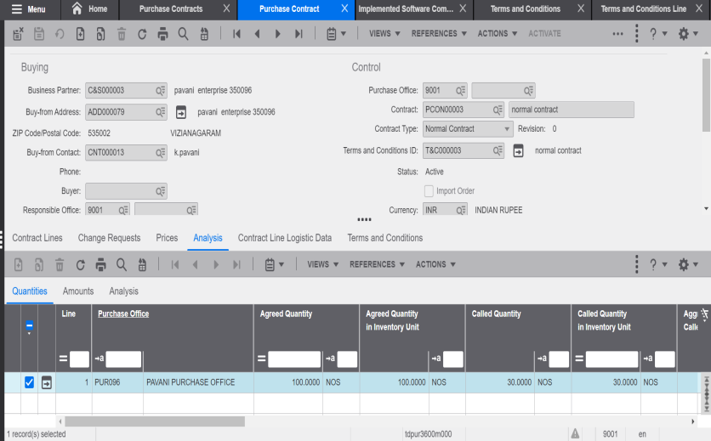

* Then terms and conditions tab will be enabled in the line level
* In the line level we can maintain item wise terms and conditions

**Terms and conditions based on:**

* Sales
* Purchase
* Internal transactions(Enterprise Unit relationships)

**Based on these three we maintain below fields:**

* Orders,Schedules,Planning,Logistics,Invoicing,Demand Pegging